Introduction
A brief account of building a software named Base Convertor based on Python Programming Language with SQLite3 – File-based SQL Database, interface for both Android and Windows platform. This is a GUI – Graphical User Interface, software built via Kivy and KivyMD, python libraries for building interactive GUI applications. Which makes it truly a user-friendly software, ease to grasp and use, even by a common human having the knowledge of decimal, binary, octal and hexadecimal number system which is vitally required.
Regarding the project file, consists of the causes and consequences of building an application software based on Python Programming Language, including installations of required software and tools, and references taken from the various sites. It concludes a detailed account for building such interactive applications.
Aim
To build a GUI (Graphical User Interface) program based on Python Programming Language and converting it to an application (.apk) as well as an executable (.exe) named Base Convertor to perform the following conversions….
- Decimal to Binary
- Binary to Decimal
- Decimal to Octal
- Octal to Decimal
- Decimal to Hexadecimal
- Hexadecimal to Decimal
- Binary to Octal
- Octal to Binary
- Binary to Hexadecimal
- Hexadecimal to Binary
- Octal to Hexadecimal
- Hexadecimal to Octal
How the software works
The software is very simple and easy to install in both android and windows just by running the apk or setup file on the device/system or by running the python script file (.py), all of them works in the same manner as followed.
- takes user input with the text field on the screen.
- results the output on the screen when convert button is pressed on the screen.
- results a message in place of output if conversion failed.
- User may change the conversion type by pressing the heading (Spinner) and selecting the relevant one.
- the history of all the valid conversions can be seen by sliding from the right end towards the left in the navigation drawer on the screen.
Advantages
- A Python Programming GUI based program, easy to use.
- Supported in all the Python supported platforms.
- Converted to an application for android and executable for windows.
- Implementation is very easy which is hard pressed for time.
- Performs all valid conversions and results a message for invalid entries.
- Provides history of all the valid conversions.
Tested Platforms
Python File (main.py) is supported in all the Python supported platforms including Kivy, KivyMD and SQLite3 (all the required libraries), tested on.
- Windows – Windows 10 Professional
- Linux – kali-linux-2023.1-virtualbox-amd64
- macOS – Sonoma 14.1.2
- Application (.apk) – supported on many android devices >= Android 2.2
  - Android 10
  - Android 11
  - Android 12
  - Android 13
- Executable (.exe) – supported on Windows 8 and newer
  - Windows 8 Ultimate
  - Windows 10 Professional
  - Windows 11 Professional
Applications Used
Listed below are the required applications used to accomplish the task i.e., software building.
- CMD (command prompt)
- Python IDLE (Integrated Development and Learning Environment)
- VS Code
- DB Browser for SQLite
- MySQL 8.0 Command Line Client
- Inno Setup
- Oracle VM VirtualBox
Problems with the software
The software won’t work only when the database file (history.db) is full of memory i.e., 140 terabytes (TB). An SQLite database is a set of pages where each page is of same size which cannot exceed 65536 bytes, and the database file has 2147483646 pages.
65536 bytes * 2147483646 pages = 140 TB (140000 GB)
Python File (main.py) – Coding & Execution
This section covers the installation of all the required dependencies, code understanding and execution of python file, main.py. Firstly, Python must be installed in the system in order to run the file and was installed from the site given below.
https://www.python.org
Latest versions of Python must be installed for the better deduce, depending on the system and note that Kivy requires Python >= 3.7. For understanding the fundamentals of python programming language, given below link can be followed.
https://www.docs.python.org/3/tutorial
Dependencies Installation – Libraries and Modules
For installation of all the required libraries and modules, CMD was opened by leading to the folder where the python file (main.py) exists and typing CMD in the directory bar and pressing enter. Easy way of opening CMD in the current working directory.
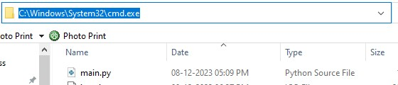
Here the moto is to open CMD in the python file directory or current working directory, thus any method of opening CMD could had been preferred but in the same python file directory.
Firstly, for getting it to know which keywork is recognized in system, the given below commands were executed on the CMD.
python –version
py –version
The working command prints the version of the Python installed in the system if none of them worked in windows means the Python is not installed. Here for this system, it was ‘python’, thus the further commands were followed by ‘python’.
Generally, ‘python’ keyword is recognized but sometimes ‘py’, which happens because of the existence of two versions of python in the system. It never changes until the reinstallation of python, removing all the python files completely from the system.
Note
Working in macOS recognizes python3 and Linux recognizes python in the terminal, rest of the things are same followed by the keyword.
PowerShell can be used instead of CMD.

Now after finding out which keyword was working, the given below command was copied (cntr + c) and pasted (cntr + p) on CMD to install all the required libraries and modules together as shown in the image.
python -m pip install kivy kivymd db-sqlite3
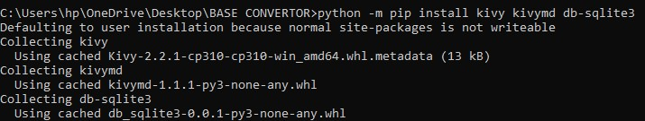
After some time, all these above-mentioned libraries and modules with depending libraries and modules were successfully installed as shown in the image.
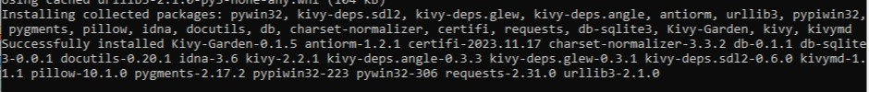
Kivy App Life Cycle
It’s very important to understand how a Kivy app works for building a Kivy application, accordingly writing the codes (script). So, I got familiar with the Kivy app cycle – states the whole process of working (mechanism) of a Kivy app, as mentioned below.
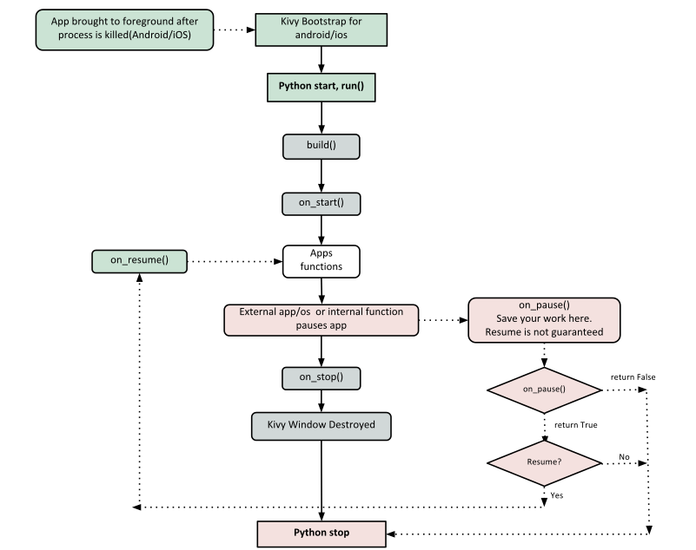
Source Code – main.py
In order to get access to the source code – attached python file, it was opened in recommended code editor, VS Code perhaps IDLE (Integrated Development for Learning Environemnt) – Python’s default code editor could had been used either.
Imported Libraries and Modules
- import os
- os.environ['KIVY_NO_CONSOLELOG'] = '1'
- from kivy.lang.builder import Builder
- from kivymd.app import MDApp
- from kivymd.uix.screen import MDScreen
- from kivymd.uix.screenmanager import MDScreenManager
- from kivymd.uix.list import ThreeLineListItem
- import sqlite3
- from datetime import datetime

There are various Functions/Modules are imported for their respective purposes in building the program whose functionalities are listed below.
OS – Operating System, is a module which comes with the default installation of python, provides a portable way of using operating system dependent functionalities.
Listed below are some functions imported from the module.
- environ – In Python, it is a mapping object that represents the user’s environmental variables. It returns a dictionary having user’s environmental variable as key and their values as value.
For more details; https://docs.python.org/3/library/os.html
Kivy – An open-source Python GUI library, provides a lot of graphics building functions/modules, can be used to develop multi-platform graphical user interface applications on Windows, Android, IOS, MacOS, Linux, and Raspberry-Pi.
There are some functions/modules used from Kivy library in the program as followed.
- DropDown – a class used to display a list of widgets under a displayed widget.
- Builder – a class responsible for creating a Parser for parsing string or kv file, merging the results into its internal rules, templates, etc.
- Spinner – a widget that provides a quick way to select one from a set.
For more details; https://www.kivy.org
KivyMD – is an extension of the Kivy GUI framework, with a wide collection of Material Design widgets, similar to Kivy framework but provides more attractive GUI.
Listed below are some KivyMD functions/modules used in the program.
- MDApp – the base class for creating KivyMD applications, which initializes everything about the program, inherited from Kivy App class.
- MDBoxLayout – a container class containing widgets arranged in sequential manner, in either a ‘vertical’ or a ‘horizontal’ orientation.
- MDFillRoundButton – a widget same as label with associated actions that are triggered when it is pressed, it is physically color filled and round shaped.
- MDLabel – a widget used for rendering text on the screen, supports ASCII and Unicode strings.
- MDList – a class defined as continuous, vertical indexes of text or images.
- MDNavigationLayout – a container class used to create navigation-based layout that allows user to flip to navigation panel from screen and vice-versa.
- MDNavigationDrawer – an empty MDCard class (panel) that provides access to destination from the left or right end in the application.
- MDScreen – a class that defines the physical size, density and resolution of a specific device.
- MDScreenManager – a widget used for managing multiple screens in an application.
- MDScrollView – a widget that provides scrollable/pannable viewport that is clipped at the scrollview’s bounding box.
- MDTextField – a widget that allows user to enter and edit text perhaps can be used to take text input from user.
- MDThreeLineListItem – a widget that defines the single element of a list having three initializing text Lines.
For more details; https://kivymd.readthedocs.io/en/1.1.1
SQLite3 – is a module written by Gerhard Haring, provides an SQL interface compliant with the DB-API 2.0 specification described by PEP 249. It is a file-based SQL database, comes bundled with Python Standard Library.
Some functions from the module have been used to store and manipulate date in database file are listed below.
- connect – connects to the database file (.db).
- cursor – creates a cursor to execute SQL commands in the database file.
- commit – use to manipulate data in the database file i.e., for DML – Data Manipulation Language commands.
For more details; https://docs.python.org/3/library/sqlite3.html
DateTime – A Python datetime module supplies classes to work with data and time, provides a number of functions to deal with dates, time and time intervals, comes bundled with Python Standard Library.
The only Function imported from this module is given below.
- now – returns the current date & time of the system.
For more details; https://docs.python.org/3/library/datetime.html
Note
There are some modules which are not imported but have been used in the builder section, notice them further in the builder section codes.

Kivy Purge
The removal of unwanted (purge) Kivy’s default debug messages is known as Kivy purge.
The second line of statement was written for stopping Kivy’s debug messages from printing on the console. It is very important when the file is converted to an executable, there will be no console for printing these statements which lead to a runtime error.
Builder – Loading KV String
This part of script was written in KV language, often called kvlang or Kivy language. It allows programmers to create their widget tree in a declarative way and to bind widget properties to each other or to callbacks in a natural manner. It allows for very fast prototypes and agile changes to their UI. It also facilitates separating the logic of the application and its User Interface.
There are two ways to load kv code into the application.
Builder.load_file(<path/to/file.kv>)
Builder.load_string(<kv code>)
A KV source constitutes of some rules which are used to describe the content of a Widget, are as followed.
Root Rule – declared by declaring the class of the root widget, without any indentation, followed by a colon (:) and will be set as the root attribute of the App instance.
Syntax – Widget:
Class/Template Rule – declared by the name of a widget class between less than and greater than sign (<, >) and followed by a colon (:), defines the appearance and behavior of any instance of that class.
Syntax – <Widget class>:
A widget class referring to a widget can be defined inside kv script itself as followed.
Syntax – <Widget class@widget>
It is same as defining a widget class referring to a widget in Python as followed.
Syntax – <Widget class>(<widget>)
Rules use indentation for delimitation, like python, four spaces per level as python style guide recommends.
- The child widgets are declared under the root widget followed by the indentation.
There are three keywords specific to kv language;
- app: always refer to the instance of the application.
- root: refers to the base widget/template in the current rule
- self: always refer to the current widget

- Builder.load_string("""

- <MyDropDown@DropDown>:
- max_height: 600

- <Home>:
- MDScreen:
- MDNavigationLayout:
- MDScreenManager:
- MDScreen:

- Spinner:
- id: spinner
- dropdown_cls: 'MyDropDown'
- size_hint: (1, 0.15)
- pos_hint: {'top': 1}
- halign: 'center'
- color: [1, 1, 1, 1]
- background_color: [0, 115, 176, 1]
- font_style: 'H6'
- font_size: root.height/24
- text: 'Decimal to Binary'
- values: ['Decimal to Binary',\
- 'Binary to Decimal',\
- 'Decimal to Octal',\
- 'Octal to Decimal',\
- 'Decimal to Hexadecimal',\
- 'Hexadecimal to Decimal',\
- 'Binary to Octal',\
- 'Octal to Binary',\
- 'Binary to Hexadecimal',\
- 'Hexadecimal to Binary',\
- 'Octal to Hexadecimal',\
- 'Hexadecimal to Octal']
- on_text: root.select()

- MDTextField:
- id: input
- hint_text: 'Enter a Decimal Number : '
- halign: 'center'
- size_hint: (0.75, 0.15)
- pos_hint: {'center_x': 0.5, 'center_y': 0.6}
- font_size: root.height/26
- on_text_validate: root.convert()

- MDLabel:
- id: label
- halign: 'center'
- pos_hint: {'center_x': 0.5, 'center_y': 0.45}
- font_style: 'Caption'
- font_size: root.height/26

- MDLabel:
- id: converted
- halign: 'center'
- pos_hint: {'center_x': 0.5, 'center_y': 0.35}
- font_style: 'Caption'
- font_size: root.height/26

- MDFillRoundFlatButton:
- id: button
- text: 'convert'
- text_color: [1, 1, 1, 1]
- pos_hint: {'center_x': 0.5, 'center_y': 0.2}
- font_style: 'Button'
- font_size: root.height/26
- on_press: root.convert()

- MDNavigationDrawer:
- anchor: 'right'
- swipe_edge_width: root.width/4
- swipe_distance: root.width/1000

- MDBoxLayout:
- id: drawer_layout
- orientation: 'vertical'
- padding: '10dp'
- spacing: '10dp'

- MDLabel:
- id: hist_label
- text: ‘No Conversion is Performed yet....’
- font_style: ‘H1’
- font_size: root.height/16

- MDScrollView:
- scroll_y: 0
- smooth_scroll_end: 100

- MDList:
- id: list
- """)

Kivy/KivyMD Widget Attributes & Parameters
- anchor – sets anchoring screen edge for navigation drawer, available options are ‘left’ and ‘right’, and by default ‘left’.
- background_color – sets background color of the widget in (r, g, b, a) format. A color property, defaults to black (grey).
- color – sets text color of the widget in (r, g, b, a) format. A color property, defaults to [1, 1, 1, 1] (white).
- dropdown_cls – sets drop-down class for spinner widget. An object property, defaults to ‘DropDown’.
- font_name – sets font of the widget’s text referring to the font file. A String property, defaults to ‘Roboto’, taken from the Config. (Used in the baseconvertor101-0.1-arm64-v8a_armeabi-v7a-debug.apk, KivyMD 1.0.2, for differentiation)
- font_size – sets font size of the widget’s text. A numeric property, defaults to 15sp.
- font_style – used to set font style of the widget’s text. Available options are; ‘H1’, ‘H2’, ‘H3’, ‘H4’, ‘H5’, ‘H6’, ‘Subtitle1’, ‘Subtitle2’, ‘Body1’, ‘Body2’, ‘Button’, ‘Caption’, ‘Overline’, ‘Icon’ and defaults to ‘Body1’.
- haling – sets the horizontal alignment of the widget’s text. Available options are; ‘auto’, ‘left’, ‘center’, ‘right’ and defaults to ‘auto’.
- id – sets a unique name of the widget for the identification of the widget outside the definition, it was declared and defaults to None.
- max_height – sets the maximum height of the opened spinner options. A numeric property, defaults to None.
- on_text – sets a method/function which is call when the spinner is clicked. A Spinner event, by default changes the spinner title to the selected value.
- on_text_validate – sets a method/function which is call when the user presses enter. A text event, by default unfocused the text input.
- orientation – sets orientation of the layout class. Available options are; ‘horizontal’, ‘vertical’ and defaults to ‘horizontal’.
- padding – sets distance between layout box and children (widgets). It is a variable list property which defaults to [0, 0, 0, 0].
- pos_hint – sets the position of the widget/layout in the screen. An object property, defaults to None.
- primary_hue – sets a primary color impact (hue) of the application. Available options are; ‘50’, ‘100’, ‘200’, ‘300’, ‘400’, ‘500’, ‘600’, ‘700’, ‘800’, ‘900’, ‘A100’, ‘A200’, ‘A400’, ‘A700’ and defaults to ‘500’.
- primary_palette – sets a specified color theme for the application. Available options are; ‘Red’, ‘Pink’, ‘Purple’, ‘DeepPurple’, ‘Indigo’, ‘Blue’, ‘LightBlue’, ‘Cyan’, ‘Teal’, ‘Green’, ‘LightGreen’, ‘Lime’, ‘Yellow’, ‘Amber’, ‘Orange’, ‘DeepOrange’, ‘Brown’, ‘Gray’, ‘BlueGray’ and defaults to ‘Blue’.
- secondary_text – sets second line text of the list item widget. A string property, defaults to None.
- scroll_y – sets the horizontal scrolling distance and defaults to None.
- size_hint – sets the size of the widget referring to the size of the application in (width, height) format. An object property, defaults to (1, 1).
- smooth_scroll_end – sets velocity of scrolling, calculated as scroll_wheel_distance * smooth_scroll_end. A numeric property, defaults to None.
- spacing – sets space between the widgets in the given class and defaults to 0.
- swipe_edge_width – sets distance up to which the sliding take place for opening the navigation drawer. A numeric property, default to 10.
- swipe_distance – sets sliding distance for opening the navigation drawer. A numeric property, defaults to 10.
- tertiary_text – sets third line text of the list item widget. A string property, defaults to None.
- text – sets text of the widget. A string property, defaults to None.
- text_color – sets text color of the widget in (r, g, b, a) format. A color property, defaults to None.
- theme_style – sets the theme style of the application. Available options are; ‘Light’, ‘Dark’, by default ‘Light’.
- values – sets options for the spinner widget. An object property, defaults to None.
Note
All these options/parameters are not supported by all the Kivy/KivyMD widgets, for more information refer to the Kivy/KivyMD documentation.

Classes and Functions
For understanding the OOPs – Object Oriented Programming, the given below can be followed.
https://www.youtube.com/watch?v=f0TrMH9s-VE
YouTube Link for Classes and Objects
ConvertorApp
The App class is the base of a Kivy App which initializes everything in the application followed by the name of app, with the MDApp keyword as a parameter.
- class ConvertorApp(MDApp):

- def build(self):
- with open ('history.db', 'a'):
- pass

- self.theme_cls.theme_style = 'Light'
- self.theme_cls.primary_palette = 'Cyan'
- self.theme_cls.primary_hue = '300'
- self.manager = MDScreenManager()
- self.manager.add_widget(Home(name = 'home'))

- return self.manager

build
A predefined function/method, responsible for initializing the whole graphics of the app and returning the root widget, and is automatically called when the program is executed. It is overridden to accomplish the following tasks.
- create a database file named ‘history.db’ if not exists.
- set the theme style of the application, by default it is ‘Light’.
- set the primary color palette of the application, by default it is ‘Blue’.
- set the primary hue of the application, by default it is ‘300’ for ‘Light’ theme.
- define a Screen Manager widget, initializes the main screen class ‘Home’ inside it.
- return the screen manager (root widget).

- def on_start(self):
- db = sqlite3.connect('history.db')
- cr = db.cursor()
- cr.execute("SELECT name FROM sqlite_master WHERE type = 'table'")

- if cr.fetchall() == []:
- cr.execute('''CREATE TABLE record(
- conversion VARCHAR(22) NOT NULL,
- deduce VARCHAR(128) NOT NULL,
- time VARCHAR(40) UNIQUE NOT NULL)''')

- else:
- cr.execute("SELECT * FROM record")
- data = cr.fetchall()

- if data != []:
- self.manager.get_screen('home').ids.drawer_layout.remove_widget(
- self.manager.get_screen('home').ids.hist_label
- )
- for row in data:
- self.manager.get_screen('home').ids.list.add_widget(
- ThreeLineListItem(
- text = row[0],
- secondary_text = row[1],
- tertiary_text = row[2],
- )
- )
- db.close()
on_start
A predefined function/method which is automatically called when the program is executed, overridden to perform the given below tasks.
- connect to the database file, ‘history.db’.
- create a table named ‘record’ if not exists.
- if exists, fetch all the record from the database into the navigation bar in a form of list item.
Home
It is a user-defined screen class containing all the definitions of the functions defining the functionalities of some of the widgets in the screen.
- class Home(MDScreen):

- def select(self):
- number = self.ids.spinner.text.split()[0]
- hint_text = f"Enter a {number} number : "

- if self.ids.input.hint_text != hint_text:
- self.ids.input.text = ""
- self.ids.label.text = ""
- self.ids.converted.text = ""
- self.ids.input.hint_text = hint_text

Select
A function defined for the selection of conversion type and called when the item of Spinner Button is pressed. When the Spinner Button is pressed, opens a wide list of all the possible conversions to select the relevant one and the function is called on selection performs the following tasks.
- Automatically changes the Spinner text to new selected conversion type.
- Stores the value of new hint text referring to spinner text in a variable named hint_text.
- If user made the new selection, then the input text, label text and converted text becomes empty and hint text changes to new hint text (hint_text).

- def convert(self):
- try:
- self.ids.label.text = f"in {self.ids.spinner.text.split()[-1]} is"

- if "." not in self.ids.input.text:

- if self.ids.spinner.text == 'Decimal to Binary':
- val = bin(int(self.ids.input.text))[2:]

- elif self.ids.spinner.text == 'Binary to Decimal':
- val = int(self.ids.input.text, 2)

- elif self.ids.spinner.text == 'Decimal to Octal':
- val = oct(int(self.ids.input.text))[2:]

- elif self.ids.spinner.text == 'Octal to Decimal':
- val = int(self.ids.input.text, 8)

- elif self.ids.spinner.text == 'Decimal to Hexadecimal':
- val = hex(int(self.ids.input.text))[2:]

- elif self.ids.spinner.text == 'Hexadecimal to Decimal':
- val = int(self.ids.input.text, 16)

- elif self.ids.spinner.text == 'Binary to Octal':
- val = oct(int(self.ids.input.text, 2))[2:]

- elif self.ids.spinner.text == 'Octal to Binary':
- val = bin(int(self.ids.input.text, 8))[2:]

- elif self.ids.spinner.text == 'Binary to Hexadecimal':
- val = hex(int(self.ids.input.text, 2))[2:]

- elif self.ids.spinner.text == 'Hexadecimal to Binary':
- val = bin(int(self.ids.input.text, 16))[2:]

- elif self.ids.spinner.text == 'Octal to Hexadecimal':
- val = hex(int(self.ids.input.text, 8))[2:]

- elif self.ids.spinner.text == 'Hexadecimal to Octal':
- val = oct(int(self.ids.input.text, 16))[2:]

- self.ids.converted.text = str(val)

- else:
- whole, fract = self.ids.input.text.split(".")

- if self.ids.spinner.text == 'Decimal to Binary':
- whole = bin(int(whole))[2:]
- fract = float("0."+fract) * 2
- floating = "."
- for i in range(10):
- floating += str(int(fract // 1))
- if fract % 1 == 0:
- break
- fract = (fract - (fract // 1)) * 2

- elif self.ids.spinner.text == 'Binary to Decimal':
- whole = int(whole, 2)
- floating = 0
- for i, digit in enumerate(fract):
- floating += int(digit, 2) * 2 ** (-(i+1))

- elif self.ids.spinner.text == 'Decimal to Octal':
- whole = oct(int(whole))[2:]
- fract = float("0."+fract) * 8
- floating = "."
- for i in range(10):
- floating += str(int(fract // 1))
- if fract % 1 == 0:
- break
- fract = (fract - (fract // 1) ) * 8

- elif self.ids.spinner.text == 'Octal to Decimal':
- whole = int(whole, 8)
- floating = 0
- for i, digit in enumerate(fract):
- floating += int(digit, 8) * 8 ** (-(i+1))

- elif self.ids.spinner.text == 'Decimal to Hexadecimal':
- whole = oct(int(whole))[2:]
- fract = float("0."+fract) * 16
- floating = "."
- for i in range(10):
- floating += str(hex(int(fract//1))[2:])
- if fract % 1 == 0:
- break
- fract = (fract - (fract // 1)) * 16

- elif self.ids.spinner.text == 'Hexadecimal to Decimal':
- whole = int(whole, 16)
- floating = 0
- for i, digit in enumerate(fract):
- floating += int(digit, 16) * 16 ** (-(i+1))

- elif self.ids.spinner.text == 'Binary to Octal':
- whole = oct(int(whole, 2))[2:]
- decimal = 0
- for i, digit in enumerate(fract):
- decimal += int(digit, 2) * 2 ** (-(i+1))
- fract = decimal * 8
- floating = "."
- for i in range(10):
- floating += str(int(fract // 1))
- if fract % 1 == 0:
- break
- fract = (fract - (fract // 1) ) * 8

- elif self.ids.spinner.text == 'Octal to Binary':
- whole = bin(int(whole, 8))[2:]
- decimal = 0
- for i, digit in enumerate(fract):
- decimal += int(digit, 8) * 8 ** (-(i+1))
- fract = decimal * 2
- floating = "."
- for i in range(10):
- floating += str(int(fract // 1))
- if fract % 1 == 0:
- break
- fract = (fract - (fract // 1) ) * 2

- elif self.ids.spinner.text == 'Binary to Hexadecimal':
- whole = hex(int(whole, 2))[2:]
- decimal = 0
- for i, digit in enumerate(fract):
- decimal += int(digit, 2) * 2 ** (-(i+1))
- fract = decimal * 16
- floating = "."
- for i in range(10):
- floating += str(hex(int(fract // 1))[2:])
- if fract % 1 == 0:
- break
- fract = (fract - (fract // 1) ) * 16

- elif self.ids.spinner.text == 'Hexadecimal to Binary':
- whole = bin(int(whole, 16))[2:]
- decimal = 0
- for i, digit in enumerate(fract):
- decimal += int(digit, 16) * 16 ** (-(i+1))
- fract = decimal * 2
- floating = "."
- for i in range(10):
- floating += str(int(fract // 1))
- if fract % 1 == 0:
- break
- fract = (fract - (fract // 1) ) * 2

- elif self.ids.spinner.text == 'Octal to Hexadecimal':
- whole = hex(int(whole, 8))[2:]
- decimal = 0
- for i, digit in enumerate(fract):
- decimal += int(digit, 8) * 8 ** (-(i+1))
- fract = decimal * 16
- floating = "."
- for i in range(10):
- floating += str(hex(int(fract // 1))[2:])
- if fract % 1 == 0:
- break
- fract = (fract - (fract // 1) ) * 16

- elif self.ids.spinner.text == 'Hexadecimal to Octal':
- whole = oct(int(whole, 16))[2:]
- decimal = 0
- for i, digit in enumerate(fract):
- decimal += int(digit, 16) * 16 ** (-(i+1))
- fract = decimal * 8
- floating = "."
- for i in range(10):
- floating += str(int(fract // 1))
- if fract % 1 == 0:
- break
- fract = (fract - (fract // 1) ) * 8

- self.ids.converted.text = str(whole + floating)

- deduce = self.ids.input.text + " = " + self.ids.converted.text
- time = str(datetime.now().strftime("%d-%m-%Y %H:%M:%S"))

- db = sqlite3.connect('history.db')
- cr = db.cursor()
- cr.execute(f'''INSERT INTO record VALUES(
- '{self.ids.spinner.text}',
- '{deduce}', '{time}')''')
- db.commit()
- db.close()

- self.ids.drawer_layout.remove_widget(self.ids.hist_label)
- self.ids.list.add_widget(
- ThreeLineListItem(
- text = self.ids.spinner.text,
- secondary_text = deduce,
- tertiary_text = time,
- )
- )

- except ValueError:
- self.ids.converted.text = ""

- if self.ids.spinner.text == 'Decimal to Binary':
- self.ids.label.text = 'Please enter a valid Decimal number'

- elif self.ids.spinner.text == 'Binary to Decimal':
- self.ids.label.text = 'Please enter a valid Binary number'

- elif self.ids.spinner.text == 'Decimal to Octal':
- self.ids.label.text = 'Please enter a valid Decimal number'

- elif self.ids.spinner.text == 'Octal to Decimal':
- self.ids.label.text = 'Please enter a valid Octal number'

- elif self.ids.spinner.text == 'Decimal to Hexadecimal':
- self.ids.label.text = 'Please enter a valid Decimal number'

- elif self.ids.spinner.text == 'Hexadecimal to Decimal':
- self.ids.label.text = 'Please enter a valid Hexadecimal number'

- elif self.ids.spinner.text == 'Binary to Octal':
- self.ids.label.text = 'Please enter a valid Binary number'

- elif self.ids.spinner.text == 'Octal to Binary':
- self.ids.label.text = 'Please enter a valid Octal number'

- elif self.ids.spinner.text == 'Binary to Hexadecimal':
- self.ids.label.text='Please enter a valid Binary number'

- elif self.ids.spinner.text == 'Hexadecimal to Binary':
- self.ids.label.text = 'Please enter a valid Hexadecimal number'

- elif self.ids.spinner.text == 'Octal to Hexadecimal':
- self.ids.label.text = 'Please enter a valid Octal number'

- elif self.ids.spinner.text == 'Hexadecimal to Octal':
- self.ids.label.text = 'Please enter a valid Hexadecimal number'

Convert
A function defined to perform the conversion in the manner given below and called when the convert button on the screen is pressed.
- Converts the label text to new label text in accordance to Spinner text.
- Analyses the type of conversion in accordance to the Spinner text.
- Tries to convert the user input to the relevant selected conversion type.
- If converted, prints the converted text on the screen and add it to the database.
- If any error occurred due to invalid input or no input, a message of invalid entry is printed on the screen in place of label text.
Kivy / KivyMD Widget’s Pre-Defined Functions
- add_widget – adds a child widget in the parent widget.
Syntax – <Widget class>.add_widget(widget, index)
- remove_widget – removes a child widget from the parent widget
Syntax – <Widget class>.remove_widget(widget)
<Widget class> – refers to the parent widget class.
widget – refers to the declaration of the child widget.
index – refers to the index place at which child widget should be added in the parent widget and defaults to 0.
ConvertorApp Run – Last Line Code

- if __name__ == "__main__" :
- ConvertorApp().run()

Finally came the last line of code to run the app but inside an if block which runs only if __name__ equals-equals ‘__main__’.
What does it mean????
Here __name__ is a very special kind of variable/attribute returns the name of the file but returns ‘__main__’ when executed by same file. Let us understand with an example, I created a file named ‘name’ which contains just two lines of code, first line is printing __name__ and second line is importing name (itself) as shown in the image.
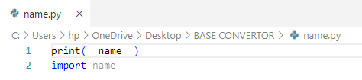
But here on execution found the difference, the first line is printing ‘__main__’ and second line is printing ‘name’ (name of the file) whereas both refers to the same file. It happened because first line __name__ is executed by itself whereas second line is importing itself where the __name__ is printed as an attribute of the imported module.
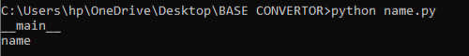
For better understanding; https://www.youtube.com/watch?v=NB5LGzmSiCs
What is the need of it????
It is very important to have this block of code to ensure that app runs only if it is executed by itself as a script not being imported from outside as a module/function. As in the above example, the variable __name__ was again printed when it was imported by itself.
Note
Each and every python file(.py) is a module in the Python Programming Language.

Running Python File
The are several ways to run python file by
- Typing given below command on CMD opened in the python file directory.
python main.py
- Opening python file in the python.exe
- Opening the python file in IDLE or VS Code and hitting F5.
Here the first option was preferred, running the file via CMD just by cntr + c and cntr + p the given command, and on hitting enter a graphical screen opened in the python.exe, as shown in the image.
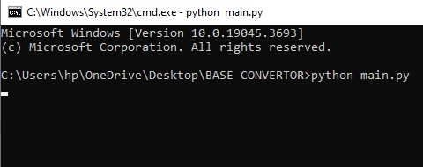
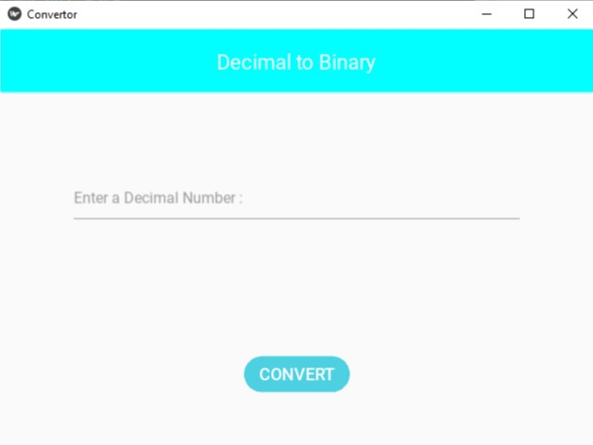
The Convertor app had started to perform the conversions, looks like a real working application. It can be reshaped with user’s choice and was working nicely in terms of use.
As expected, nothing was printed on the CMD as the Kivy default print statements were blocked above in the script, line number – 2.

Noticed the change, Immediately, after the execution a new database file named ‘history.db’ was created in the python file directory as expected, shown in the image.
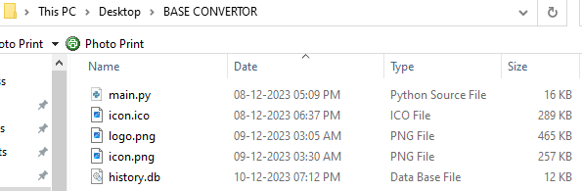
Database File – history.db
A database file created when the python file (main.py) was executed, stores the history of conversions in a tabular form in the table named ‘record’ as shown in the image.
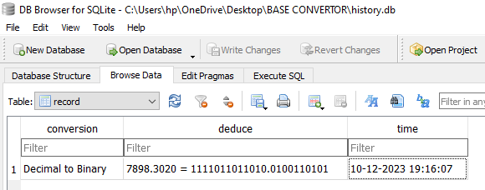
Above in the image, the database file was opened in DB Browser for SQLite on the system which was installed from the link given below.
https://sqlitebrowser.org/dl
Python with MySQL
Here in the above script the SQLite3 database had been used, which can be replaced by MySQL – RDBMS (Relational Database Management System) with some changes in the script as followed.
Firstly, MySQL must be installed on the system which was made from the link given below.
https://dev.mysql.com/downloads/mysql
For using the MySQL database in Python, mysql-connector-python module is required, which was installed by executing the command given below in CMD.
python -m pip install mysql-connector-python
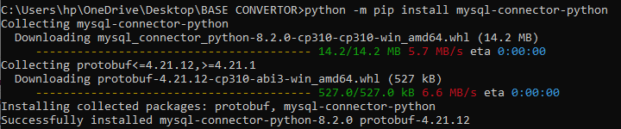
After the installation of mysql-connector-python module, it should be imported in the script, in place of SQLite3 as followed.
- import mysql.connector

Since MySQL server doesn’t require any database file, therefore the below mentioned lines should be removed from the python script file.
- with open ('history.db', 'a+'):
- pass
Here MySQL database should be connected in place of SQLite3 database file as followed.
- db = mysql.connector.connect(
host = 'localhost',
user = 'root',
passwd = '1234567',
database = 'history')
- db = mysql.connector.connect(
host = 'localhost',
user = 'root',
passwd = '1234567',
database = 'history')
Parameters
- host – name of the host of the system.
- user – name of the user of the MySQL server.
- passwd – password of the MySQL server for the current user.
- database – name of the database to be connected.
Generally, the host is ‘localhost’ and the user is ‘root’. And here the database ‘history’ was created just before the execution of the python script file by executing the query given below on the MySQL 8.0 Command Line Client.
CREATE DATABASE history;
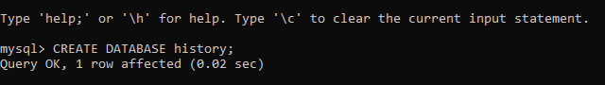
Note
The above-mentioned arguments are for the current used system. Thus, these won’t work in all the systems, hence the arguments must be changed according to the system preferences.

Lastly a SQLite3 QUERY for finding out the tables in the current database should be changed as followed.
- cr.execute("SHOW TABLES")
  - Noted as a QUERY difference between SQLite3 & MySQL
After configuring out all these changes, the script is ready for execution. And on execution, worked same as before but here created a table in the MySQL database which can be seen through the MySQL 8.0 Command Line Client by executing some queries as shown in the image.
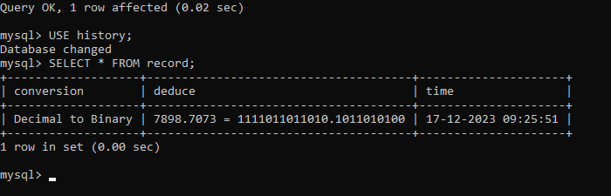
Here in the image, first query was for changing Database and Second query was for selecting all the records from table ‘record’.
Executable File (.exe) Building
Building an executable from a python file is a very essential part which requires a python tool named PyInstaller – responsible for building python file to an executable file.
PyInstaller Installation
To accomplish the task of building an executable file, PyInstaller was installed via pip by executing the given below command on CMD.
python -m pip install pyinstaller
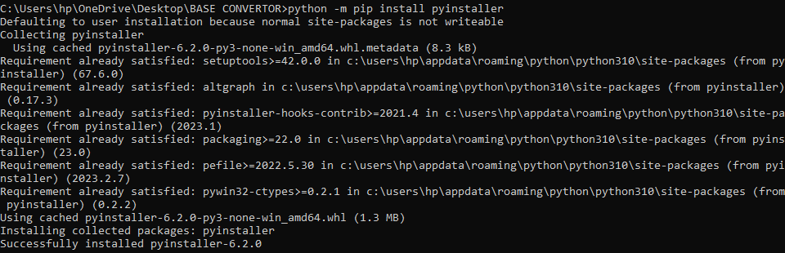
After the successful installation, the given below command was executed to build executable.
python -m PyInstaller ^
--name <appname> ^
--icon <icon file> ^
--noconsole --onefile ^
<python file>
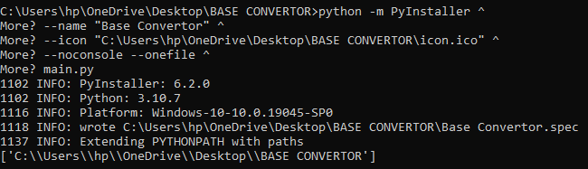
Options & Tags
- --name – used to set name for the application.
- <appname> – refers to the name of the application. (user’s choice)
- --icon – used to set icon for the application.
- <icon file> – refers to the path to the icon file for the application.
- --noconsole – used to build executable console free.
- --onefile – used to build just an executable file.
- <python file> – refers to the python file (main.py).
- <spec file> – refers to the spec file (Base Convertor.spec).
For more details; https://www.pyinstaller.org/en/stable/spec-files.html
Note
-- (double-dash) symbol is used in most batch/bash built-in commands and many other commands to signify the end of command options (arguments).
^ (circumflex) symbol is used for continuation of command to next line in CMD.
\ (backslash) symbol is used for continuation of command to next line in terminal in macOS/Linux.
Icon file must be an ICO file (.ico).

After execution of last command, a new spec file was created followed by the exe name and two new folders, build and dist with an executable file (.exe) inside it were created as shown in the image.
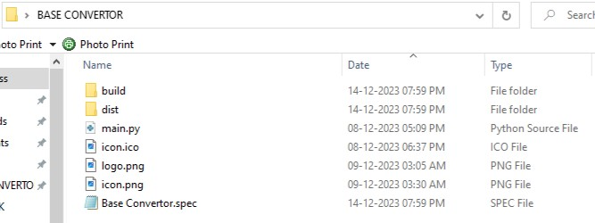
But unfortunately, executable raised an error on execution as shown in the image.
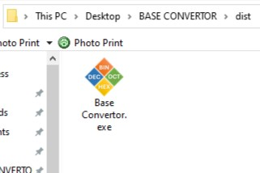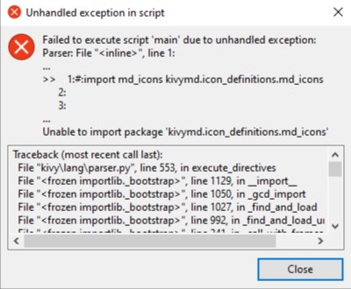

Spec File Configuration
To resolve the issue, some corrections were done in the spec file (Base Convertor.spec) as followed.
Firstly, some required Kivy and KivyMD modules were imported.
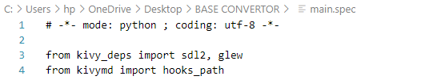
Forwardly, path for KivyMD hidden imports was added in hidden imports option in Analysis class.
Lastly, tree of the python file folder was added in EXE class to access all the executable files (component files). Since executable didn’t have any pre-defined component file, thus it is not recommended, perhaps could had been skipped either.
And tree of the sdl2 and glew was also added in EXE class to access all the functions of SDL2 library from the application and GLEW, to provide efficient run-time mechanisms for determining which OpenGL extensions are supported on the target platform.
Note
The Base Convertor.spec file is for customization of executable. There are a lot more customizations which can be made for better results but not mentioned here, just the essential customizations.

Now, after the changes, saving the file, the given below command was executed.
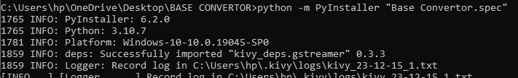
python -m PyInstaller <spec file>
Note
The spec file was having space in the file name thus it was quoted by double-inverted commas (“”) to prevent the ‘script not found’ error.

Here the last command was successfully executed in about 10 mins depending on the system as shown in the image. And here all the issues had been resolved, the executable file was working properly on the system.
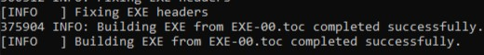
Note
PyInstaller works same for macOS and Linux as well. The above commands may be used for the same, building regular executable for Linux and a. app bundle for macOS with slight modifications.

Executable to Setup Wizard
For setting a setup wizard file for executable, Inno Setup had been used which was installed from the link given below.
https://jrsoftware.org/isdl.php
Firstly, the Inno Setup was opened and ‘Create a new script file using the Script Wizard’ => Next => Next was selected. Where it asked for the name, version, publisher, website of the Application as shown in the image.
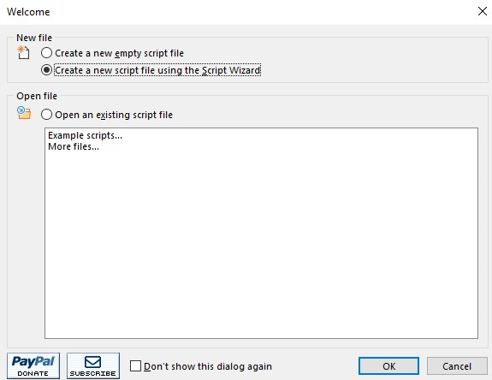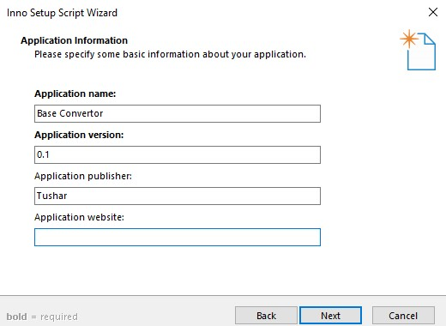
Here the Application version, publisher, website was not vitally required, thus Application website was skipped.
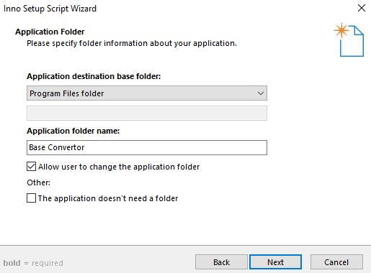
After the data had been feed, the Next button was clicked to move to the next slide where it asked for the path to the Application destination base folder where the application should be saved on the system after the installation of application by running setup wizard and name of the Application folder as shown in the image.

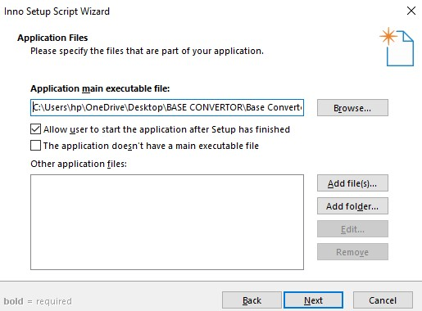
Again, the Next button was clicked after the data had been feed. And here it asked for the path to the exe file for which the setup was being done and other application files (component files) as shown in the image.
Since the application doesn’t have any pre-defined component file, thus the ‘Other application files’ section is empty.

Clicking the Next button again after feeding the required data, moved to the next slide asked to specify the executable file association which was skipped as it didn’t have any associated file type extension. And again, the Next button was clicked and moved to the next slide asked to setup application shortcut as shown in the image.
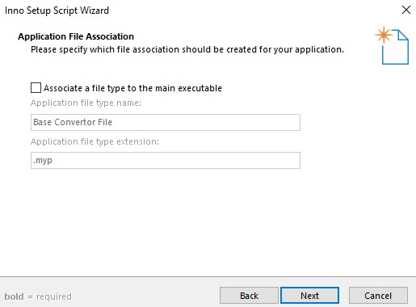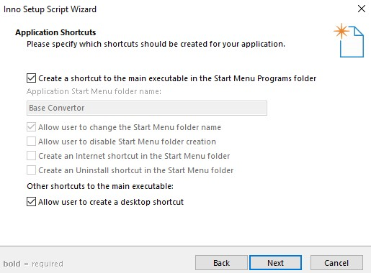

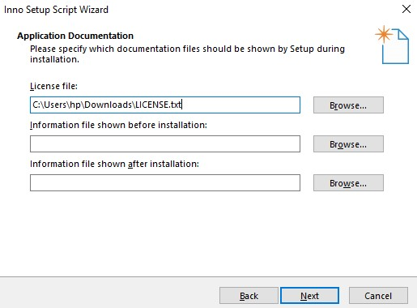
Here again by clicking Next button moved to the application documentation slide asking for the path to the license file, information file before & after the installation which should be shown by Setup Wizard during installation, as shown in the image.
Here these documentation files were not vitally required, thus only the LICENSE.txt was uploaded which was downloaded from the internet, a common license agreement used by most of the applications.

The Next button was clicked again, moved to the next slide asked to specify setup installation mode as shown in the image. And again, moving to the next slide asked to specify the setup languages should be included for the application as shown in the image.
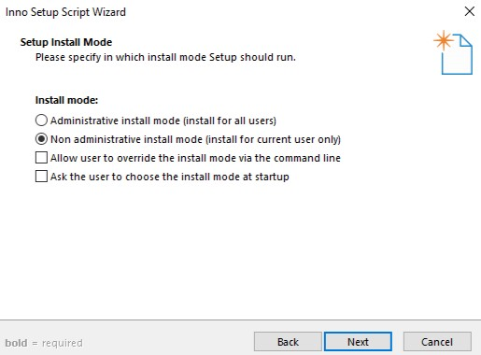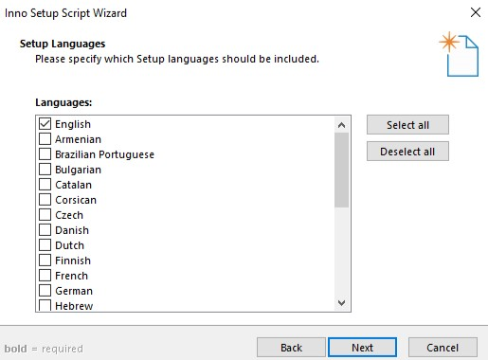

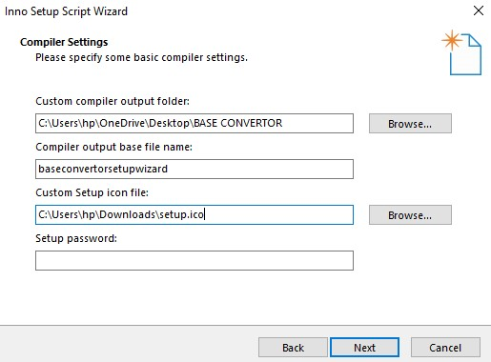
Again, moving to the next slide by clicking Next button, asked for the path where the Setup Wizard should be stored (exported) in the system, setup file name and icon file path and setting up a password which is not essential, thus it is empty, as shown in the image.
Here the setup.ico file is downloaded from the internet, a commonly used window setup icon file.

Again, moving to the next slide, asked for consent to use Inno Setup Compiler to build setup file, thus it was permitted as shown in the image. And finally came the last slide by clicking last next button on the previous slide, stated that the Inno Setup Script Wizard had been successfully completed and asked to click the Finish button to close wizard and generate the new script file as shown in the image.
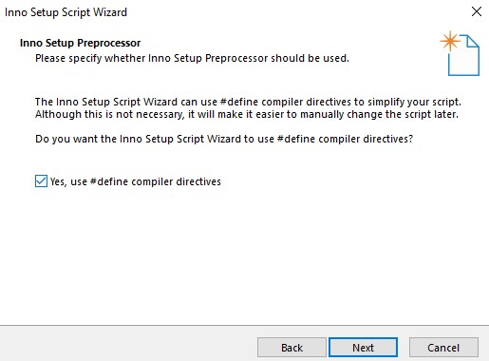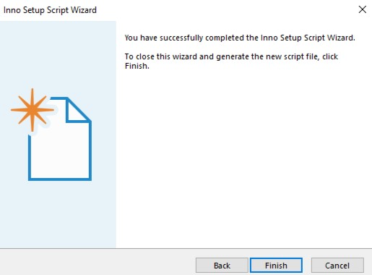
After the Finish button was clicked, the new script file was generated and opened where it asked for compiling, hence the Yes button was pressed to compile the new script now and No button was pressed for saving the script before compiling, as shown in the images.
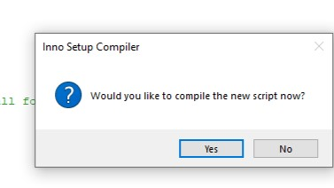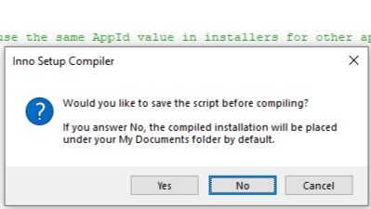
Here after the compilation, the setup wizard file was generated in the BASE CONVERTOR Folder which was selected above for storing it, as shown in the image.
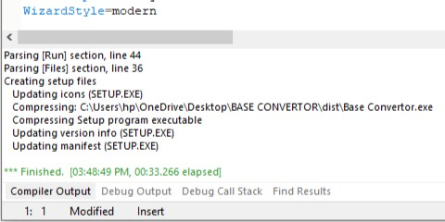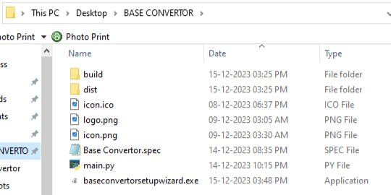
Executable Installation via Setup Wizard
For the installation of setup wizard, the setup wizard file needed to be shared to the system via any method either by Mail, WhatsApp, Bluetooth, Wi-Fi/nearby share or by cable/connector/pen-drive.
After the setup wizard file was shared using pen-drive, the setup wizard file throwed these types of screens on execution as followed.
Firstly, introduced a License Agreement screen as shown in the image. After moving to the next slide, it asked to set the path where the application folder should be installed and defaults to …\AppData\Local\Programs\Base Convertor (installation for current user) as shown in the image.
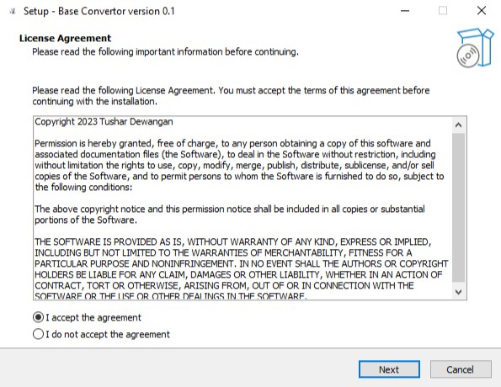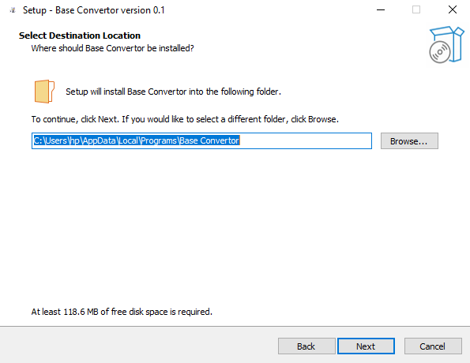
Moving to the next slide, asked to create a desktop shortcut for the application as shown in the image. And on the next slide, provided a summary of installation besides confirmed for the application package installation as shown in the image.
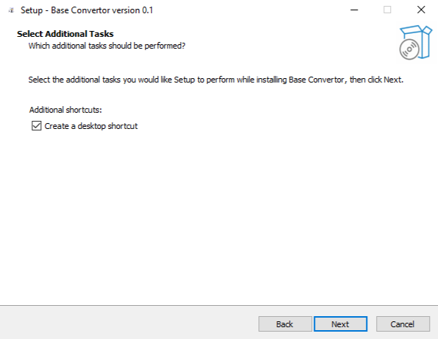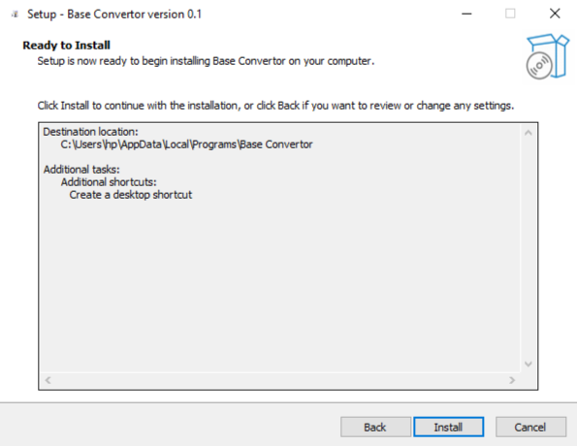
On clicking Install button, confirming the surety of installation, application package installation started on the next screen and provides an option to Cancel as shown in the image. After some time depending on the system, moved to last screen stated that the installation is completed and asked to Launch Base Convertor hence click the Finish button to exit Setup, as shown in the image.
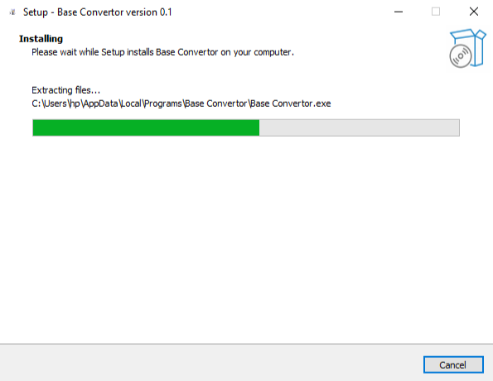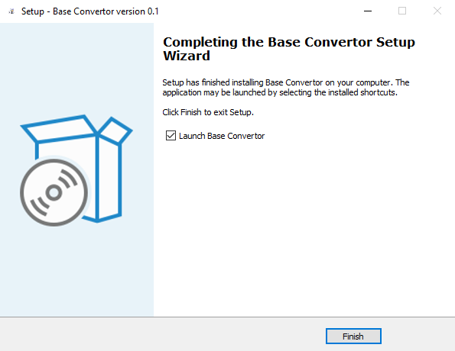
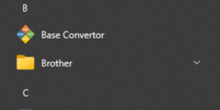
After Finishing the setup, the application, Base Convertor had been successfully installed on the system hence a shortcut file was created in the Start Menu as well as in the Desktop as selected above in the setup configuration, as shown in the image.
The Application has its own customized icon which is the same icon.ico file installed during building executable via PyInstaller. For more details, heed to the executable file (.exe) building section, page number – 19.
Since PyInstaller is supported on Windows 8 and newer, thus exe is not supported on older versions.
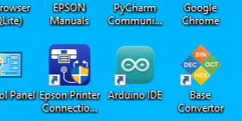
Application File (.apk) Building
There are various ways of converting python file (.py) to application file (.apk)
- Linux/Ubuntu
- Google Colab
- GitHub
Here the Google Colab method had been used, the most elementary method for most of the users.
Google Colab – Apk File Formation
Moving to the Google Colab page and executing all the commands mentioned in the given below link would let the apk file built.
https://colab.research.google.com/drive/1wFVii8gFyVV4XseDU3g8Au8k-gKje0Cc?usp=sharing
  - Link to the Google Colab page used for building this apk file.
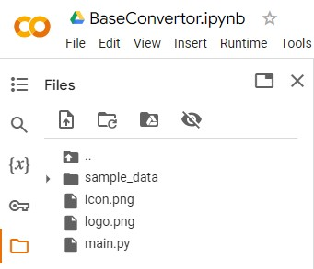
But before executing the commands, python file with all the application’s files (component files) must be uploaded in the Files section. And there must be a main.py file no so conversion will be failed, vitally required in all the three ways mentioned above.
Since the program doesn’t requires any pre-defined component file. Therefore, there are two image files, logo.png for pre-splash of application on starting and icon.png for icon of the application with main.py file, were uploaded in the Files section, as shown in the image.
The given below command was executed for the installation of all the required tools via apt-get command as shown in the image.
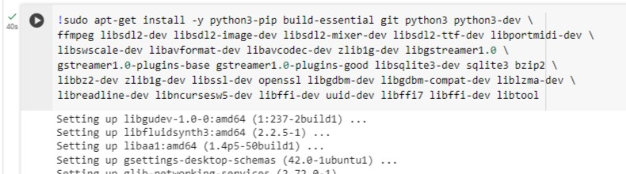
The given below command was executed for the installation of required libraries via python pip as shown in the image.
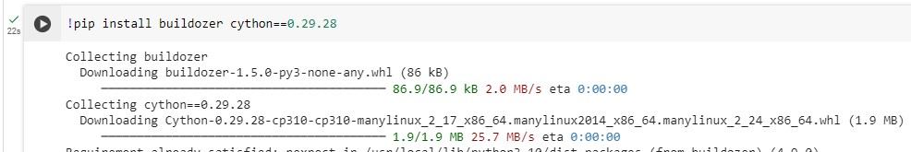
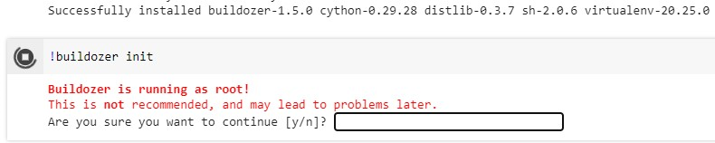
After the successful installation of all the dependencies via pip command, the second last command was executed, asked for the surety of execution of command as shown in the image.

Buildozer File Configuration
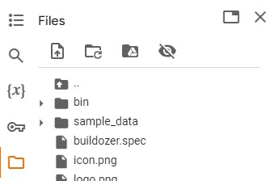
On confirming the surety which was recommended, immediately a spec file named buildozer.spec was loaded in the Files section as shown in the image, which was needed to be customized as followed.

Setting the title of the Application and package name – User’s Choice.
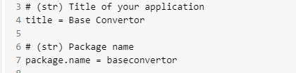
Mentioning all the required file extensions which are supposed to be supported by the Application. Here no extensions were required, thus no editing was done.
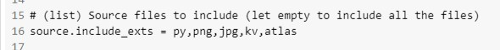
Mentioning all the dependencies – libraries and modules used to build the program. Here mentioning the Kivy and KivyMD versions is essential for a true conversion.
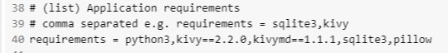
Lastly, adding the pre-splash and icon files for the application by removing # from the beginning of the line to uncomment it and by editing names of the files as shown in the image.
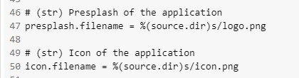
Note
The buildozer.spec file is for customization of application. There are a lot more customizations which can be made for better results but not mentioned here, just the essential customizations.

After configuring out the changes and closing the file which is automatically saved. The last command was executed, again asked for the surety of execution of command as shown in the image.
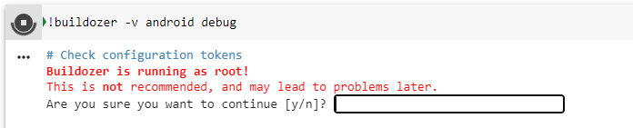
Repeating the same thing again confirming the surety which was recommended for building apk, asked for signing a license agreement, android-sdk-license: the Android Software Development Kit License Agreement with Google Inc., which was needed to be accepted as followed.
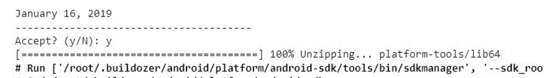
In about 20 to 25 mins depending on the system reached the destination, two beautiful blue lines were printed on the screen told that “the apk file has been built and loaded in the bin folder in the Files section” as shown in the image.
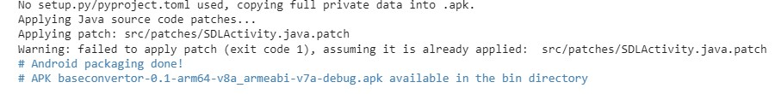
Note
All these command works perfectly in the Linux Terminal to build apk file, just by removing ‘!’ from the beginning of the command.

Application (.apk) File Installation
For the installation of apk in the android, built apk file needed to be shared to the android device by any of method either by Mail, WhatsApp, Bluetooth, Wi-Fi/nearby share or by cable/connector.

Here it had been shared with WhatsApp which on installation, throws these kind of screens as followed.
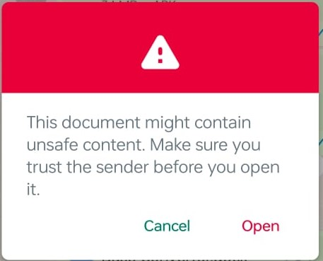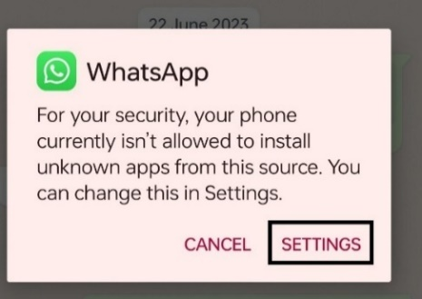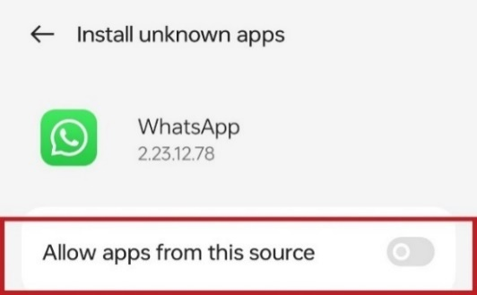
After allowing apps (apk files) shared by WhatsApp, the apk file throws these kind of screens on installation of app as followed.
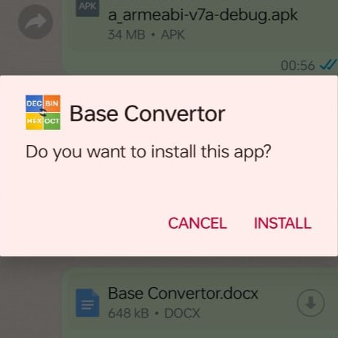
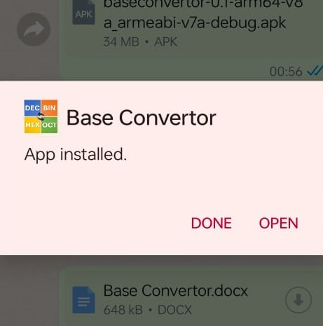
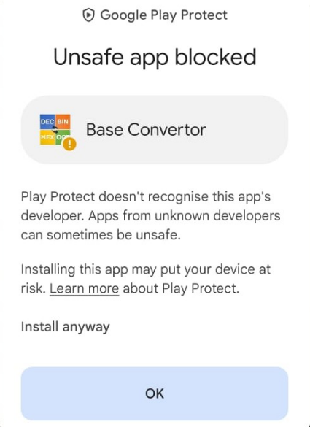

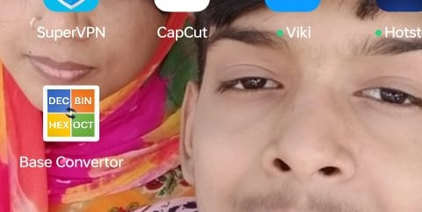
Here the application had been installed on the android device with its own customized icon pasted on the device’s screen as shown in the image.

This is the same icon file, icon.png loaded in the application package (.apk) during application building. For more details, heed to the application file (.apk) building section, page no. – 27.

Note
The above two security and setting screens are founded only if any application has been used for sharing the apk file i.e., WhatsApp. And the rest below installation screens are common.

Runtime Error
On hitting the application, perfectly opened on my device but immediately got closed on another device. Though opening it continuously for three-four times thrown a dialog box, signified a runtime error that “Base Convertor is experiencing crashes”. This error had been determined and debugged by switching to Kali Linux and performing some operations.
Kali Linux – Adb Commands Execution
For using Kali Linux, Kali Linux virtual machine was set up in Oracle VM VirtualBox which were installed from the links given below.
https://www.virtualbox.org/wiki/Downloads
https://www.kali.org/get-kali/#kali-platforms
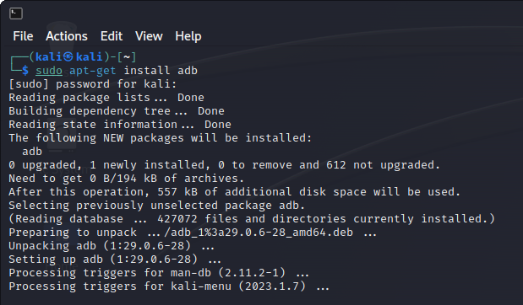
As shown in the image, terminal was opened on the Kali Linux running as a Virtual Machine on the Oracle VM VirtualBox. To determine the error, adb – android debug bridge was essential which was installed by executing the command given below.
sudo apt-get install adb

After the installation of adb, the android device was to connected to the Kali Linux Virtual Machine with a cable/connector. After the successful connection, on the device, gone to setting -> About device -> Version -> pressed the Build number 7 times enabled Developer Options to perform adb commands on the device to configure out the error.
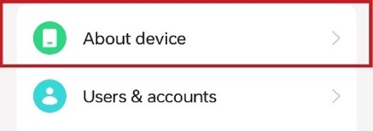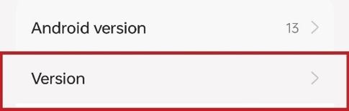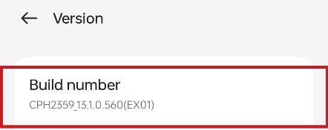
After enabling the developer options, it was added to the additional setting which wasopened to enable USB debugging as followed.
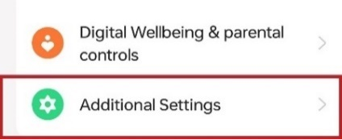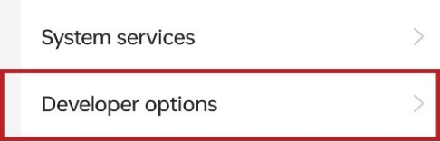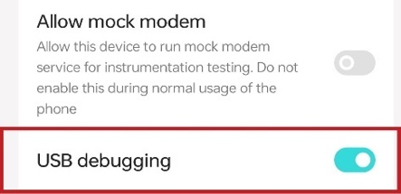
Once the USB debugging was enabled, the final command was ready to be executed to determine the error which is as mentioned below.
adb logcat
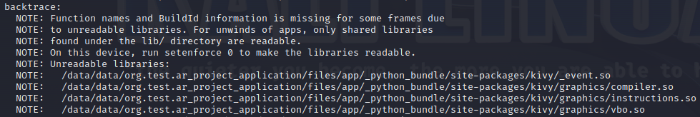
On searching, it was found that the error was caused because of KivyMD version which is not supported by all the android devices. This issue had been resolved by rebuilding apk with a slightly older version of KivyMD, 1.0.2, supported by many android devices >= Android 2.2.
Note
The last command cannot be executed in Google Colab to determine the run-time error.

Output – Base Convertor
The section covers all kinds of output resulted by the application.
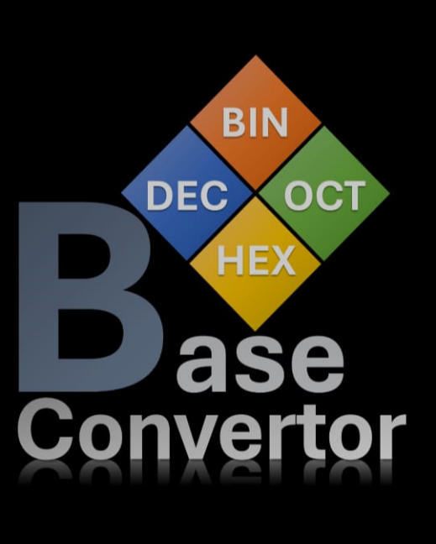
Pre-splash of the Application
When the application is opened in the device, a pre-splash is displayed on the screen as shown in the image, until the actual display is loaded for performing the conversions.
This is the image file, logo.png which was uploaded in the application packaging for pre-splash of the application while building apk file.
For more details, heed to the application file (.apk) building section, page number – 27.

Application Screen’s Widgets
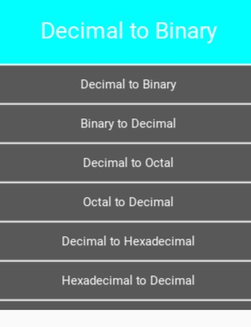
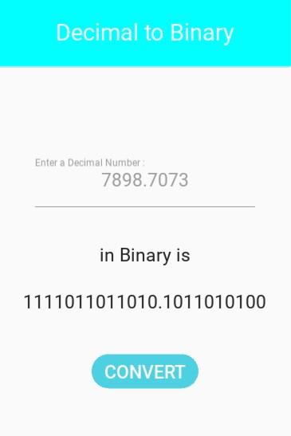
Spinner
The title of the conversion which on press, opens an options menu containing all types of possible conversion performed by the application for the selection of type of conversion in accordance to the user’s desire, by default it is Decimal to Binary.

MDLabel
Renders the converted text or a valid user input message on the screen. And there are two labels were used for the same. By Default, renders nothing on the screen.

MDTextField
Responsible for taking user input for the conversion, and has a hint text defined for the type of user input in accordance to the selected conversion type. Here by default, it is empty (“”).

MDFillRoundFlatButton
Converts the user input to the selected conversion type on press, if converted results the converted text on the screen and save the recently performed conversion into the database file else results a message for a valid user input on the screen.

Conversions Performed
Practically performed conversions with the outcomes.
Decimal to Binary
The above conversion can be made by performing integer division (floor division) of decimal number before decimal point by 2 and noting down the remainder, and again performing integer division of quotient by 2 and noting down the remainder, the same process should be repeated until the quotient is 0. And for the numbers after decimal point, performing multiplication by 2 and noting down the integer value each time until the number after the decimal point is 0. Reversing the noted remainders and writing the noted integers after the decimal point is the result.
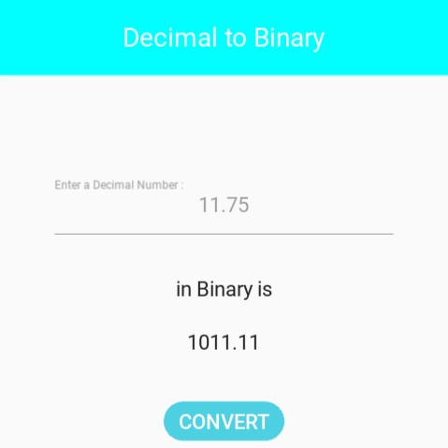
Ex. (11.75)₁₀ = (1011.11)₂
2 | 11 |  | 1
2 | 5 |  | 1
2 | 2 |  | 0
2 | 1 |  | 1
 | 0
0.75 x 2 = 1.5 1
0.5 x 2 = 1.0 1

Binary to Decimal
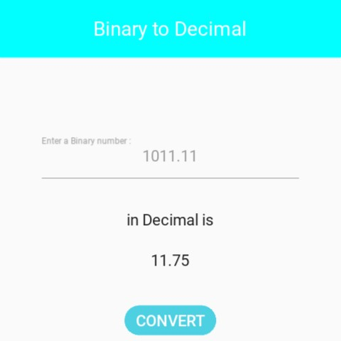
The Method of converting binary number to decimal number is by performing addition of multiplication of each binary digit by 2 having the power counted from right end starting from zero before decimal and negative power from left to right after decimal starting from -1.
Ex. (1011.11)₂ = (11)₁₀
= 1 x 2³ + 0 x 2² + 1 x 2¹ + 1 x 2⁰ + 1 x 2⁻¹ + 1 x 2⁻²
= 8 + 0 + 2 + 1 + 0.5 +0.25
= 11.75

Decimal to Octal
The above conversion can be made by performing integer division of decimal number before decimal point by 8 and noting down the remainder, and again performing integer division of quotient by 8 and noting down the remainder, the same process should be repeated until the quotient is 0. And for the numbers after decimal point, performing multiplication by 8 and noting down the integer value each time until the number after the decimal point is 0. Reversing the noted remainders and writing the noted integers after the decimal point is the result.
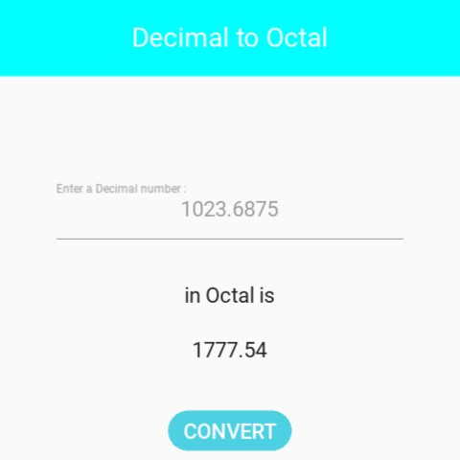
Ex. (1023.6875)₁₀ = (1777.54)₈
8 | 1023 |  | 7
8 | 127 |  | 7
8 | 15 |  | 7
8 | 1 |  | 1
 | 0
0.6875 x 8 = 5.5 5
0.5 x 8 = 4.0 4

Octal to Decimal
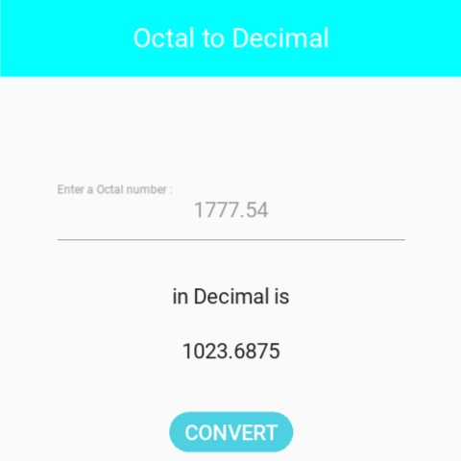
The Method of converting octal number to decimal number is by performing addition of multiplication of each octal digit by 8 having the power counted from right end starting from zero before decimal and negative power from left to right after decimal starting from -1.
Ex. (1777.54)₈ = (1023.6875)₁₀
= 1 x 8³ + 7 x 8² + 7 x 8¹ + 7 x 8⁰ + 5 x 8⁻¹ + 4 x 8⁻²
= 512 + 448 + 56 + 7 + 0.625 + 0.0625
= 1023.6875

Decimal to Hexadecimal
The above conversion can be made by performing integer division of decimal number before decimal point by 16 and noting down the remainder, and again performing integer division of quotient by 16 and noting down the remainder, the same process should be repeated until the quotient is 0. And for the numbers after decimal point, performing multiplication by 16 and noting down the integer value each time until the number after the decimal point is 0. Reversing the noted remainders and writing the noted integers after the decimal point is the result.
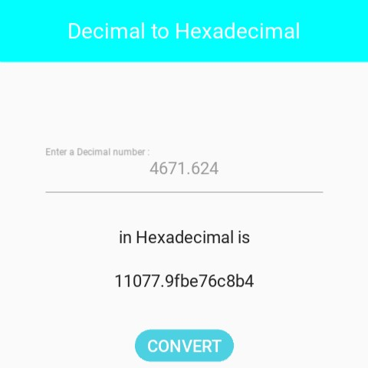
Ex. (4671.624)₁₀ = (123f.9fbe76)₁₆
16 | 4671 |  | 15(f)
16 | 291 |  | 3
16 | 18 |  | 2
16 | 1 |  | 1
 | 0
0.624 x 16 = 9.984 9
0.984 x 16 = 15.744 15(f)
0.744 x 16 = 11.904 11(b)
0.904 x 16 = 14.464 14(e)
0.464 x 16 = 7.424 7
0.424 x 16 = 6.724 6
Hexadecimal to Decimal
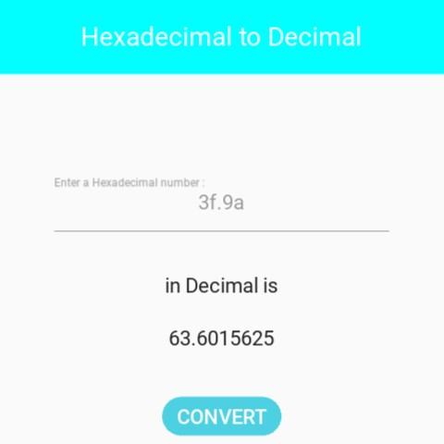
The Method of converting hexadecimal number to decimal number is by performing addition of multiplication of each hexadecimal digit by 16 having the power counted from right end starting from zero before decimal and negative power from left to right after decimal starting from -1.
Ex. (3f.9a)₁₆ = (63.6015625)₁₀
= 3 x 16¹ + 15(f) x 16⁰ + 9 x 16 + 10(a) x 16
= 48 + 15 + 0.5625 + 0.0390625
= 63.6015625

Binary to Octal
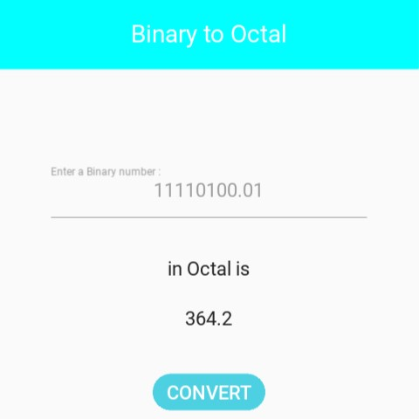
Binary numbers can be converted to octal numbers by splitting binary number into the group of three binary digits from the right end before the decimal point and from the left after the decimal point. By converting each group to their respective decimal form and writing them together in the same order it was before is the result.
Ex. (11110100.01)₂ = (364.2)₈
11 110 100 01 (splitting)
011 = 3
110 = 6
100 = 4
010 = 2
= 364.2

Octal to Binary
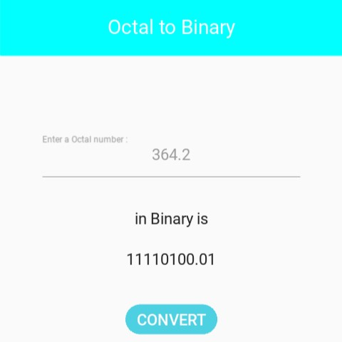
The above conversion can be performed by changing each octal digit to their respective binary form in a group of three bit, treating each octal digit as a decimal digit.
Ex. (364.2)₈ = (11110100.01)₂
3 = 011
6 = 110
4 = 100
2 = 010
= 011110100.010
Note
Since the base of octal number is 8. Hence octal number act as decimal number for the first eight octal numbers i.e., 0, 1, 2, 3, 4, 5, 6, 7 (octal digits).
The highest three-digit binary number is 111 equals 7 in both decimal and octal i.e.
(111)₂ = (7)₁₀ = (7)₈. Thus, binary/octal number has been divided/assigned in groups of three bits.

Binary to Hexadecimal
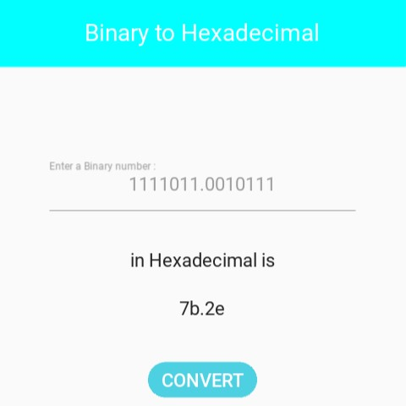
The above conversion can be performed by splitting binary number into the group of four binary digits from the right end before the decimal point and from the left after the decimal point. By converting each group to their respective decimal form and writing them together in same order it was before is the result.
Ex. (1111011.0010111)₂ = (7b.2e)₁₆
111 1011 0010 111 (splitting)
0111 = 7
1011 = 11(b)
0010 = 2
1110 = 14(e)
= 7b.2e

Hexadecimal to Binary
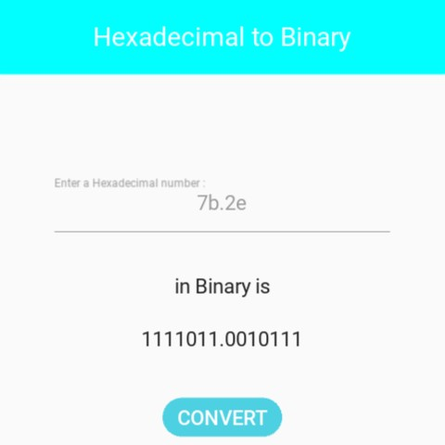
The above conversion can be performed by changing each hexadecimal digit to their respective binary form in a group of four bit, treating each hexadecimal digit as a decimal digit.
Ex. (7b.2e)₁₆ = (1111011.0010111)₂
7 = 0111
11(b) = 1011
2 = 0010
14(e) = 1110
= 01111011.00101110
Note
Since the base of hexadecimal number is 16. Hence hexadecimal number act as decimal number for the first sixteen hexadecimal numbers i.e., 0, 1, 2, 3, 4, 5, 6, 7, 8, 9, a (10), b (11), c (12), d (13), e (14), f (15) (hexadecimal digits).
The highest four-digit binary number is 1111 equals 15 in both decimal and hexadecimal i.e.
(1111)₂ = (15)₁₀ = (15)₁₆. Thus, binary/hexadecimal number has been divided/assigned in groups of 4 bits.

Octal to Hexadecimal
There is no direct or shortcut method to perform the above conversion, it can only be performed either by converting octal to decimal or octal to binary and then decimal/binary to hexadecimal.
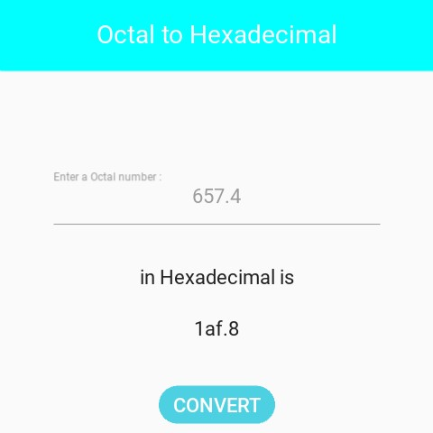
Ex. (657.4)₈ = (1af.8)₁₆
6 = 110 5 = 101
7 = 111 4 = 100
= 110101111.100

1 1010 1111 100 (splitting)
0001 = 1 1010 = 10(a)
1111 = 15(f) 1000 = 8
= 1af.8

Hexadecimal to Octal
Same as Octal to Hexadecimal there is no direct or shortcut method to perform the above conversion, it can only be performed either by converting hexadecimal to decimal or hexadecimal to binary and then decimal/binary to octal.
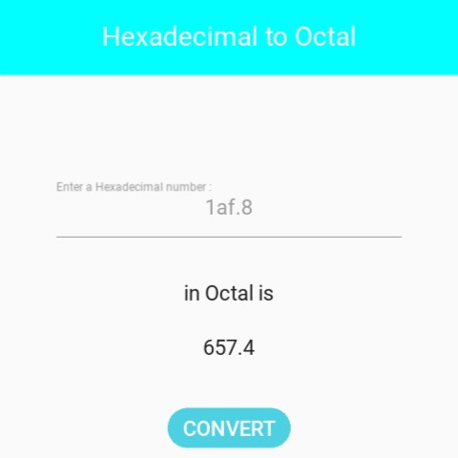
Ex. (1af.8)₁₆ = (657.4)₈
1 = 0001 10(a) = 1010
15(f) = 1111 8 = 1000
= 000110101111.1000

110 101 111 100 (splitting)
110 = 6 101 = 5
111 = 7 100 = 4
= 657.4

Navigation Drawer – History
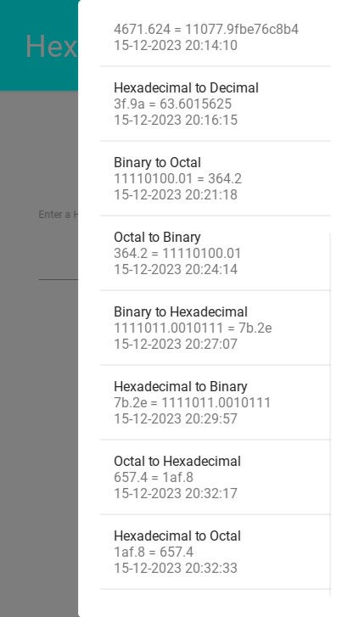
The Navigation Drawer is an empty MDCard class which can be customized according to programmer’s intention, and displays App’s navigation option from the left/right edge of the screen.
Here it has been used as a plane navigation drawer with a MDList containing all the history records of valid conversions if exists otherwise displays a message, “No Valid Conversion is Performed yet” as a MDLabel. The Drawer can be opened by pressed slide from right end towards left on the screen containing all the successful conversions in the form of list with type of conversion, value and deduce and date and time of the conversion.

MDThreeLineListItem
It is a KivyMD widget used for rendering details of each valid conversion performed by the application as an element of MDList in the Navigation Drawer.

References
Listed below are some links to references taken and installations made sites.
Python – https://www.python.org
- https://www.docs.python.org/3/tutorial
- https://pypi.org/project/Kivy
- https://pypi.org/project/kivymd
- https://docs.python.org/3/library/os.html
- https://docs.python.org/3/library/sqlite3.html
- https://docs.python.org/3/library/datetime.html
- https://pypi.org/project/mysql-connector-python
- https://www.pyinstaller.org/en/stable/spec-files.html
Kivy – https://www.kivy.org
- https://kivy.org/doc/stable/api-kivy.uix.dropdown.html
- https://kivy.org/doc/stable/api-kivy.lang.builder.html
- https://kivy.org/doc/stable/api-kivy.uix.spinner.html
KivyMD – https://kivymd.readthedocs.io/en/1.1.1
- https://kivymd.readthedocs.io/en/1.1.1/themes/material-app/index.html
- https://kivymd.readthedocs.io/en/1.1.1/components/boxlayout/index.html
- https://kivymd.readthedocs.io/en/1.1.1/components/button/index.html
- https://kivymd.readthedocs.io/en/1.1.1/components/label/index.html
- https://kivymd.readthedocs.io/en/1.1.1/components/list/index.html
- https://kivymd.readthedocs.io/en/1.1.1/components/navigationdrawer/index.html
- https://kivymd.readthedocs.io/en/1.1.1/components/screen/index.html
- https://kivymd.readthedocs.io/en/1.1.1/components/screenmanager/index.html
- https://kivymd.readthedocs.io/en/1.1.1/components/scrollview/index.html
- https://kivymd.readthedocs.io/en/1.1.1/components/textfield/index.html
Python Simplified - https://www.youtube.com/c/PythonSimplified
- https://www.youtube.com/watch?v=ah3JeHAfM0M
- https://www.youtube.com/watch?v=f0TrMH9s-VE
- https://www.youtube.com/watch?v=NB5LGzmSiCs
- https://www.youtube.com/watch?v=p3tSLatmGvU
VS Code – https://code.visualstudio.com
DB Browser for SQLite – https://sqlitebrowser.org
MySQL – https://dev.mysql.com/downloads/mysql
Inno Setup – https://jrsoftware.org/isinfo.php
Oracle VM VirtualBox – https://www.virtualbox.org/wiki/Downloads
Kali Linux Virtual Machine – https://www.kali.org/get-kali/#kali-platforms

